**5 - ELECTRICAL DESIGN AND SENSOR SYSTEMS**

The main focus is to maintain simplicity. To achieve this, the electrical system consists of several compact, modular, and easily accessible PCBs and sensors. This system of PCBs will be mounted onto the front section of the robot chassis. It will enclosed by an aluminum sheet-metal box, protected with an inner layer of HDPE plastic.

**5.1 Sensors**

5.1.1 Reflectance Sensors

There will be 6 QRD1114 Infrared Reflective Optosensors. Two sensors are to be used as wheel encoders, mounted by the rear driving wheels. For tape following, two parallel, downward facing sensors will be securely mounted under the front section of the chassis. The remaining two sensors will also be mounted under the chassis, but located on the left and right side to detect pet location tape markings.

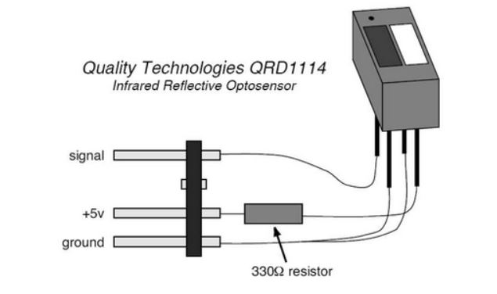

FIGURE # : Infrared Reflective Optosensor

5.1.2 Press-Button Sensors

There will be six microswitch sensors. Three are to be mounted at the front of the chassis, one centered and two on each side. They will extend past any extruding part of the robot, and be used for collision detection. One sensor will be mounted on the arm, to detect the presence of an attached pet. The remaining two sensors will be used to detect the single occurring processes of the robot; the zip-line mechanism and the catapult release.

5.1.3 Beacon-Detection Sensors

Two infrared sensors (QRD124 Phototransistors) will be securely mounted in an outward facing position on the front of the chassis. They will be used to locate the beacons.

**5.2 Circuits**

1 x Central PCB Hub (Power (+15/+9/-9), Ground, TINAH inputs/outputs)

This PCB acts as a central hub for all subsequent circuits, power sources and TINAH inputs/outputs. The only dedicated rails will be +15V, +9V, -9V, Ground, two IR Sensor Circuit TINAH inputs, and 3 Zener H-Bridge TINAH outputs. The board will have extra rails with female header pins, to accommodate other TINAH inputs/outputs and any future modifications.

----->INSERT HUB PCB FIGURE<-----

2 x IR Sensor Circuit

There will be two Infrared Sensor Circuits, each built on separate PCBs. They will be connected to the +9V/-9V/Ground rails from the central hub.

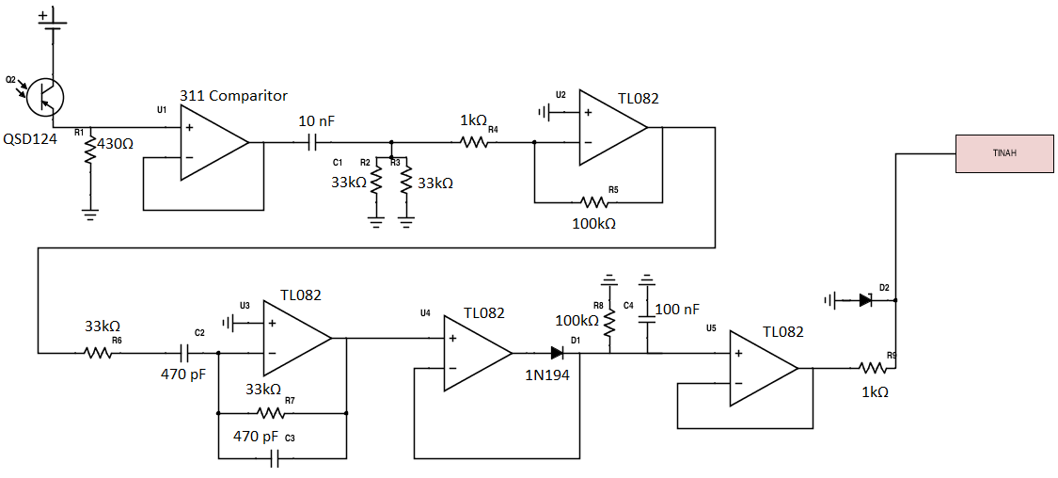

FIGURE # : Infrared Sensor Circuit

3 x Zener H - Bridge Circuit

Three Zener H-Bridge PCBs will be constructed to drive the two Barber-Colman geared motors and zip-line lift apparatus. They will be connected to the -15V/Ground rails from the central hub.

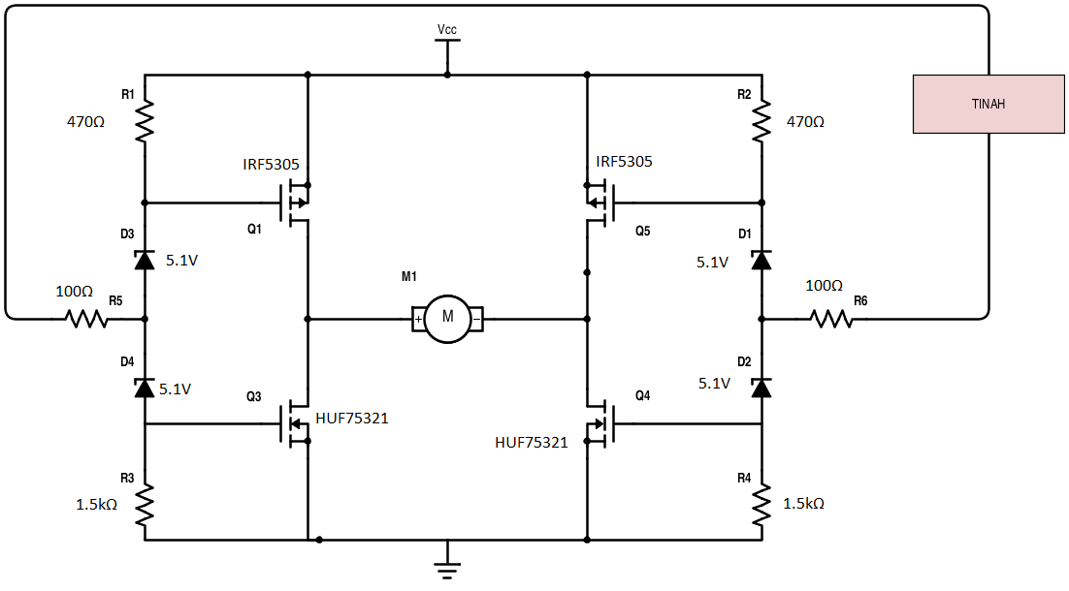

FIGURE # : Zener H-Bridge Circuit

**5.3 TINAH Resources**

TINAH Analog Input / Output Allocation

|  |  |
| --- | --- |
| TINAH Analog Pin Number | Device |
| 0 | Left Wheel Encoder Sensor |
| 1 | Right Wheel Encoder Sensor |
| 2 | Left Tape (Follow) Sensor |
| 3 | Right Tape (Follow) Sensor |
| 4 | Left Tape (Pet Marking) Sensor |
| 5 | Right Tape (Pet Marking) Sensor |
| 6 | Left IR Sensor |
| 7 | Right IR Sensor |

TINAH Digital Input / Output Allocation

|  |  |
| --- | --- |
| TINAH Digital Pin Number | Device |
| 0 | Pet Pickup Button |
| 1 | Zip-line Mechanism Release Button |
| 2 | Catapult Release Button |
| 3 | Left Collision Button |
| 4 | Centeral Collision Button |
| 5 | Right Collision Button |